**Film Production Management System**

**Scenario Description:**

A film production house is a dynamic hub where the entire process of making a movie comes together. The producer oversees the hiring of key professionals, such as directors, marketing teams, finance teams, and creative specialists like set designers and make-up artists. Directors manage the auditions and casting, while screenwriters craft the story. The creative team handles the visual elements, and the marketing team ensures the film reaches the right audience. Every department works together, from budgeting and writing to shooting and editing, all to bring a film from concept to screen.

**Objective**:

To create an ER Diagram and identifying the entities, attributes and their Relationship, also to map their Cardinalities. And finally creating a relational database according to the ER diagram drawn.

**Tools Used:** Draw.io

**Concept**:

Organizing data into entities, attributes, and relationships to reflect real-world processes. It ensures data integrity, clarity, and smooth management of interconnected tasks in a structured database system.

**Solution:**

Entities:

Producer (Strong Entity)

Director (Strong Entity)

Marketing (Strong Entity)

Screenwriters (Strong Entity)

Cast (Strong Entity)

Audition (Strong Entity)

Creative Team (Strong Entity)

Film (Strong Entity)

Finance Team(Strong Entity)

Attributes:

* Producer
  + p_id (Primary Key): single valued
  + p_name: composite
  + p_dob: simple
  + p_age: derieved
  + p_phno: multivalued
  + p_email: mulltivalued
* Director
  + d_id (Primary Key): single valued
  + d_name: composite
  + d_age: simple
  + d_phno: multivalued
  + d_email: multivalued
* Marketing
  + m_id (Primary Key): single valued
  + m_phno: multivalued
  + m_budget: simple
  + m_timeframe: composite (start date, end date)
* Screenwriters
  + sw_id (Primary Key): single valued
  + sw_name: simple
  + script_id: single valued
  + script_name: simple
* Cast
  + c_id (Primary Key): single valued
  + c_name: simple
  + c_role: multivalued
* Audition
  + a_id (Primary Key): single valued
  + a_venue: simple
  + a_date: simple
  + audtionee: composite.
* Creative Team
  + Creative Team
    - Set makers
      * sm_id(Primary Key): single valued
      * sm_speciality: multivalued
    - Make-up artists & fashion designers
      * ma_id: (Primary Key): single valued
      * ma_speciality: multivalued
      * fd_id: (Primary Key): single valued
      * fd_speciality: multivalued
    - Editors
      * ed_id(Primary Key): single valued
      * ed_speciality: multivalued
* Film
  + f_id (Primary Key): single valued
  + f_name: simple
  + f_release_date: composite (day, month, year)
  + f_length: simple
  + f_language: multivalued
* Finance Team
  + fi_id (Primary Key): single valued
  + fi_phno: multivalued
  + assigned_budget: simple

Relationship:

1. Producer **Hires** Director
2. Producer **Hires** Marketing team
3. Producer **Hires** Finance team
4. Producer **Hires** Creative team
5. Producer **Hires** Screen Writers
6. Producer **Produces** Film
7. Director **Directs** Film
8. Director **Conducts** Audition
9. Director **Finalizes** Cast
10. Cast **Acts for** Film
11. Marketing **Markets** Film
12. Finance Team **Is Responsible for** Budgeting
13. Screen Writers **Writes for** Film
14. Creative Team **Works on** Film

Cardinalities:

**One** Producer hires **Many** Directors.

**One** Producer hires **One** Marketing Team.

**One** Producer hires **One** Finance Team.

**One** Producer hires **One** Creative Team.

**One** Producer hires **Many** Screenwriters.

**One** Producer Produces **One** Film.

**Many** Directors Directs **One** Film.

**Many** Directors Conducts **Many** Auditions.

**Many** Directors Finalizes **One** Cast.

**One** Cast Acts for **One** Film.

**One** Marketing Markets **One** Film.

**One** Finance Team is responsible for budgeting **One** Film.

**Many** Screenwriters Write for **One** Film.

**Many** Creative Team Works on **One** Film.

ER Diagram:

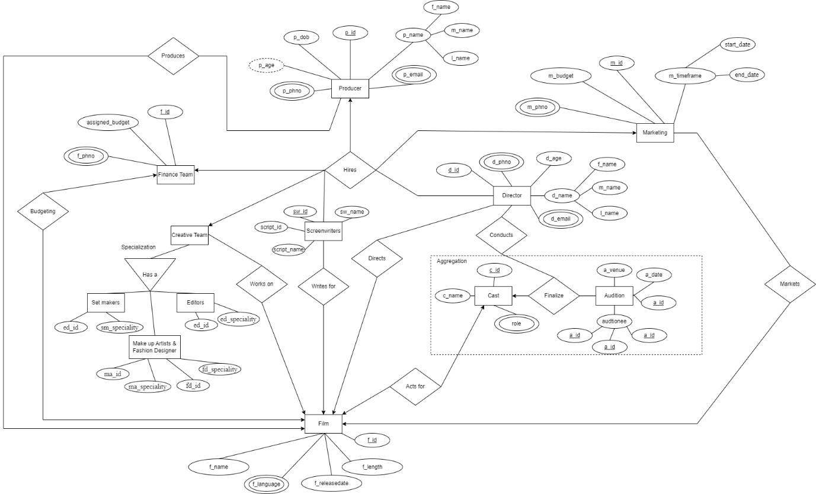

**Relational Database**

**One** Producer hires **Many** Directors

|  |  |  |  |  |
| --- | --- | --- | --- | --- |
| p_id | f_name | m_name | l_name | p_age |
|  |  |  |  |  |

|  |  |
| --- | --- |
| p_id | p_email |
|  |  |

|  |  |
| --- | --- |
| p_id | p_phno |
|  |  |

|  |  |
| --- | --- |
| p_id | d_id |
|  |  |

|  |  |  |  |  |
| --- | --- | --- | --- | --- |
| d_id | f_name | m_name | l_name | d_age |
|  |  |  |  |  |

|  |  |
| --- | --- |
| d_id | d_email |
|  |  |

|  |  |
| --- | --- |
| d_id | d_phno |
|  |  |

**One** Producer hires **One** Marketing Team.

|  |  |  |  |  |
| --- | --- | --- | --- | --- |
| p_id | f_name | m_name | l_name | p_age |
|  |  |  |  |  |

|  |  |
| --- | --- |
| p_id | p_email |
|  |  |

|  |  |
| --- | --- |
| p_id | p_phno |
|  |  |

|  |  |
| --- | --- |
| p_id | m_id |
|  |  |

|  |  |  |  |
| --- | --- | --- | --- |
| m_id | m_budget | Start_date | Start_date |
|  |  |  |  |

|  |  |
| --- | --- |
| m_id | p_phno |
|  |  |

**One** Producer hires **One** Finance Team.

|  |  |  |  |  |
| --- | --- | --- | --- | --- |
| p_id | f_name | m_name | l_name | p_age |
|  |  |  |  |  |

|  |  |
| --- | --- |
| p_id | p_email |
|  |  |

|  |  |
| --- | --- |
| p_id | p_phno |
|  |  |

|  |  |
| --- | --- |
| p_id | fi_id |
|  |  |

|  |  |
| --- | --- |
| fi_id | assigned_budget |
|  |  |

|  |  |
| --- | --- |
| p_id | p_phno |
|  |  |

**One** Producer hires **One** Creative Team

|  |  |  |  |  |
| --- | --- | --- | --- | --- |
| p_id | f_name | m_name | l_name | p_age |
|  |  |  |  |  |

|  |  |
| --- | --- |
| p_id | p_email |
|  |  |

|  |  |
| --- | --- |
| p_id | p_phno |
|  |  |

|  |  |  |  |
| --- | --- | --- | --- |
| p_id | sm_id | ma_id | ed_id |
|  |  |  |  |

Creative Team

Set Makers

|  |  |
| --- | --- |
| sm_id | sm_speciality |
|  |  |

Make-up artists & fashion designers

|  |  |  |  |
| --- | --- | --- | --- |
| ma_id | ma_speciality | fd_id | fd_id |
|  |  |  |  |

Editors

|  |  |
| --- | --- |
| ed_id | ed_speciality |
|  |  |

**One** Producer hires **Many** Screenwriters

|  |  |  |  |  |
| --- | --- | --- | --- | --- |
| p_id | f_name | m_name | l_name | p_age |
|  |  |  |  |  |

|  |  |
| --- | --- |
| p_id | p_email |
|  |  |

|  |  |
| --- | --- |
| p_id | p_phno |
|  |  |

|  |  |
| --- | --- |
| p_id | sw_id |
|  |  |

|  |  |  |  |
| --- | --- | --- | --- |
| sw_id | sw_name | script_id | script_id |
|  |  |  |  |

**One** Producer Produces **One** Film

|  |  |  |  |  |
| --- | --- | --- | --- | --- |
| p_id | f_name | m_name | l_name | p_age |
|  |  |  |  |  |

|  |  |
| --- | --- |
| p_id | p_email |
|  |  |

|  |  |
| --- | --- |
| p_id | p_phno |
|  |  |

|  |  |
| --- | --- |
| p_id | f_id |
|  |  |

|  |  |  |  |  |
| --- | --- | --- | --- | --- |
| f_id | f_name | f_release_date | f_length | f_language |
|  |  |  |  |  |

**Many** Directors Directs **One** Film

|  |  |  |  |  |
| --- | --- | --- | --- | --- |
| d_id | f_name | m_name | l_name | d_age |
|  |  |  |  |  |

|  |  |
| --- | --- |
| d_id | d_email |
|  |  |

|  |  |
| --- | --- |
| d_id | d_phno |
|  |  |

|  |  |
| --- | --- |
| d_id | f_id |
|  |  |

|  |  |  |  |  |
| --- | --- | --- | --- | --- |
| f_id | f_name | f_release_date | f_length | f_language |
|  |  |  |  |  |

**Many** Directors Conducts **Many** Auditions

|  |  |  |  |  |
| --- | --- | --- | --- | --- |
| d_id | f_name | m_name | l_name | d_age |
|  |  |  |  |  |

|  |  |
| --- | --- |
| d_id | d_email |
|  |  |

|  |  |
| --- | --- |
| d_id | d_phno |
|  |  |

|  |  |
| --- | --- |
| d_id | a_id |
|  |  |

|  |  |  |
| --- | --- | --- |
| a_id | a_venue | a_date |
|  |  |  |

|  |  |
| --- | --- |
| a_id | audtionee |
|  |  |

**Many** Directors Finalizes **One** Cast

|  |  |  |  |  |
| --- | --- | --- | --- | --- |
| d_id | f_name | m_name | l_name | d_age |
|  |  |  |  |  |

|  |  |
| --- | --- |
| d_id | d_email |
|  |  |

|  |  |
| --- | --- |
| d_id | d_phno |
|  |  |

|  |  |
| --- | --- |
| d_id | c_id |
|  |  |

|  |  |  |
| --- | --- | --- |
| c_id | c_ name | c_role |
|  |  |  |

**One** Cast Acts for **One** Film

|  |  |  |
| --- | --- | --- |
| c_id | c_ name | c_role |
|  |  |  |

|  |  |
| --- | --- |
| c_id | f_id |
|  |  |

|  |  |  |  |  |
| --- | --- | --- | --- | --- |
| f_id | f_name | f_release_date | f_length | f_language |
|  |  |  |  |  |

**One** Marketing Markets **One** Film

|  |  |  |  |
| --- | --- | --- | --- |
| m_id | m_budget | Start_date | Start_date |
|  |  |  |  |

|  |  |
| --- | --- |
| m_id | p_phno |
|  |  |

|  |  |
| --- | --- |
| m_id | f_id |
|  |  |

|  |  |  |  |  |
| --- | --- | --- | --- | --- |
| f_id | f_name | f_release_date | f_length | f_language |
|  |  |  |  |  |

**One** Finance Team is responsible for budgeting **One** Film

|  |  |
| --- | --- |
| fi_id | assigned_budget |
|  |  |

|  |  |
| --- | --- |
| fi_id | fi_phno |
|  |  |

|  |  |
| --- | --- |
| fi_id | f_id |
|  |  |

|  |  |  |  |  |
| --- | --- | --- | --- | --- |
| f_id | f_name | f_release_date | f_length | f_language |
|  |  |  |  |  |

**Many** Screenwriters Write for **One** Film

|  |  |  |  |
| --- | --- | --- | --- |
| sw_id | sw_name | script_id | script_id |
|  |  |  |  |

|  |  |
| --- | --- |
| sw_id | f_id |
|  |  |

|  |  |  |  |  |
| --- | --- | --- | --- | --- |
| f_id | f_name | f_release_date | f_length | f_language |
|  |  |  |  |  |

**Many** Creative Team Works on **One** Film

Creative Team

Set Makers

|  |  |
| --- | --- |
| sm_id | sm_speciality |
|  |  |

Make-up artists & fashion designers

|  |  |  |  |
| --- | --- | --- | --- |
| ma_id | ma_speciality | fd_id | fd_id |
|  |  |  |  |

Editors

|  |  |
| --- | --- |
| ed_id | ed_id |
|  |  |

|  |  |  |  |
| --- | --- | --- | --- |
| sm_id | ma_id | ed_id | f_id |
|  |  |  |  |

|  |  |  |  |  |
| --- | --- | --- | --- | --- |
| f_id | f_name | f_release_date | f_length | f_language |
|  |  |  | s |  |

**Observation**:  
The Film Production Management System organizes the entire process of making a movie using a clear and simple database design. It includes key Entities as roles like the producer, director, marketing team, screenwriters, cast, and more, each with their own attributes and tasks. The relationships between these roles, such as hiring teams, conducting auditions, and budgeting, are well-defined. The database ensures all tasks, from planning to release, are connected and managed smoothly. This design is easy to use and helps keep the complex film production process organized and efficient.